BICS Skills + Platform User Guide
Welcome to the BICS Platform.
Lantra have redeveloped the BICS platform to improve performance and support future development.
This guide will give you a few hints and tips for using the BICS platform.
If you need further assistance, please contact the Associate Project Manager at Lantra:
danni.fagan-shaw@lantra.co.uk or email bridges@lantra.co.uk.
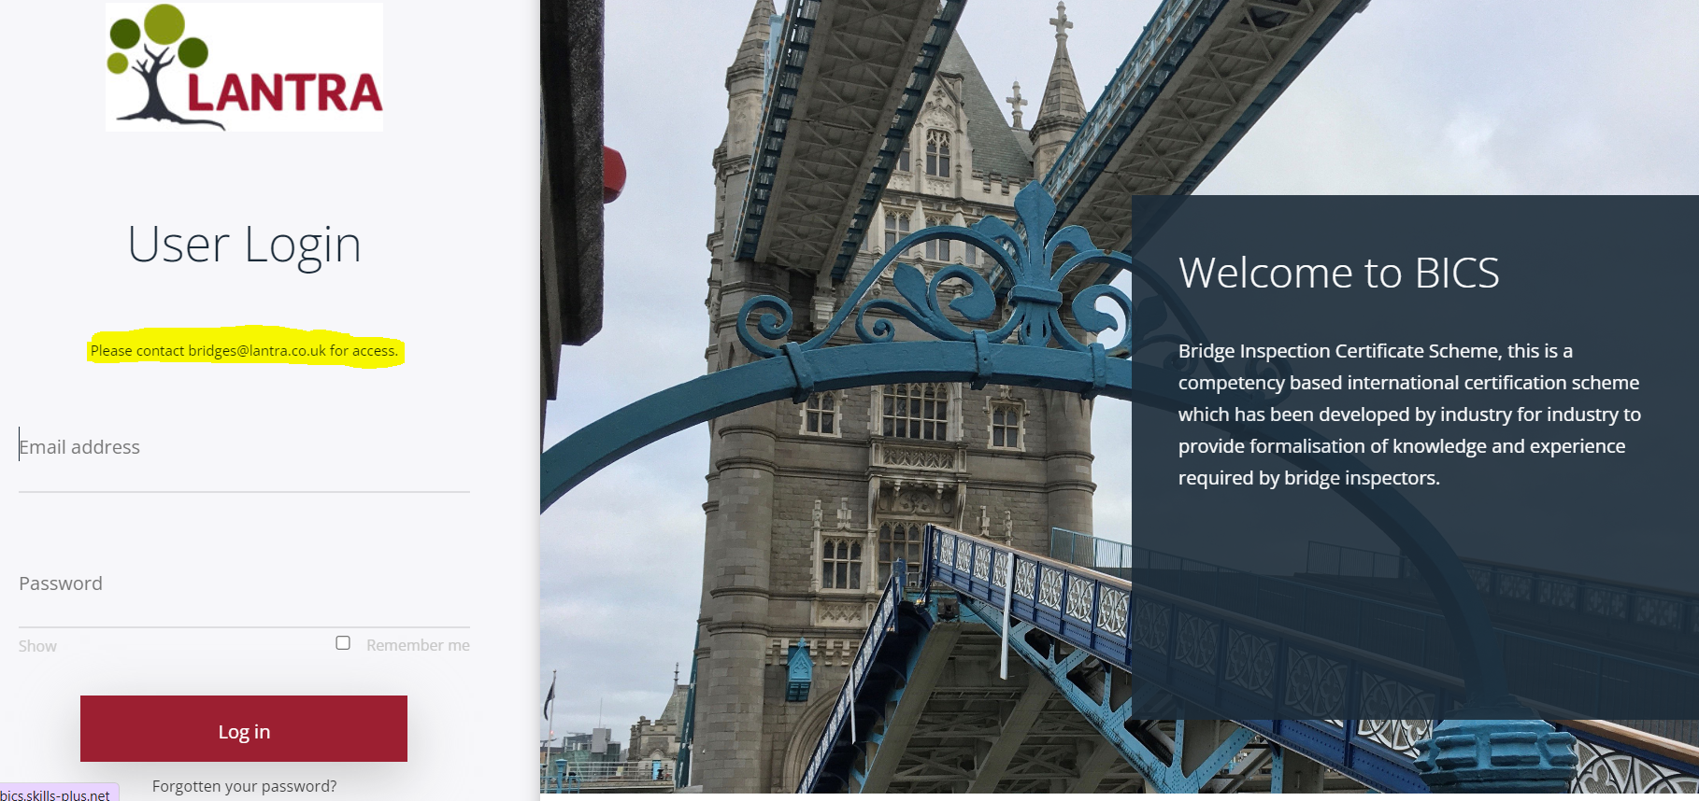
Login Page
New user registration: Please contact bridges@lantra.co.uk
To register, an invoice will be sent to you/your company which includes registration, access to the BICS platform*, submission and assessment of portfolio upon completion, a professional interview and an initial 3-year certification fee.
﻿*if you do not access your account within the first two years a re-activation fee may be applicable.
Lantra will then create your e-portfolio and send you your username and password.
BICS Pricing Structure
The pricing is as follows and are inclusive of VAT and all processing fees.
Core + One module | £710 |  | Cost includes:  - Core+ selected modules*  (*You must select core + One module to become BICS Certified)  - Portfolio assessment costs  - Professional interview cost  (upon successful pass of e-portfolio)  - Issue of e-card as proof of BICS Certification
Core + Two modules | £740
Core + Three modules | £770
Single module | £400 |  | Cost for further modules
Resubmission/Resit | £300 |  | Cost for resubmission of e-portfolio following failure  Cost for Re-interview following failure
Annual Renewal | £150 |  | Once a Certified Bridge Inspector (BI)/Senior Bridge Inspector (SBI) there is an annual membership fee (renewable on 1 April annually)

My Profile
This is where your personal profile information is held. You can update your details and add a photo in this section, you also have the option to change your password and username.
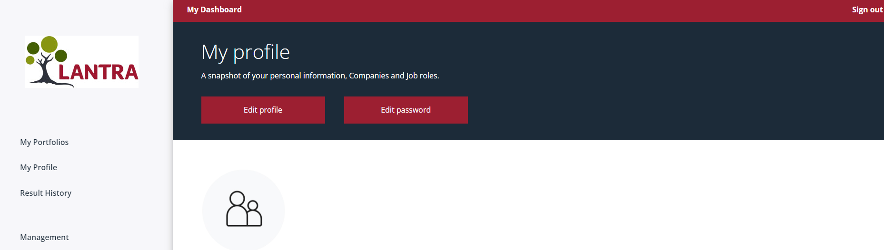

My Dashboard
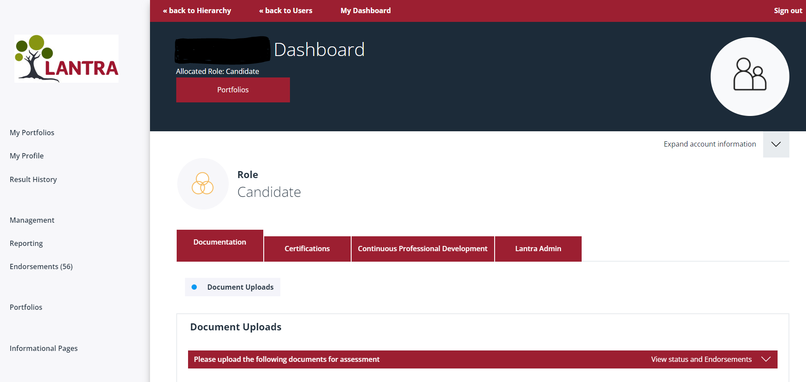
To access your BICS portfolio click on the portfolio button beneath your username as above:
Once in your portfolio you will see the modules you have access to, this will reflect the package that you have purchased.
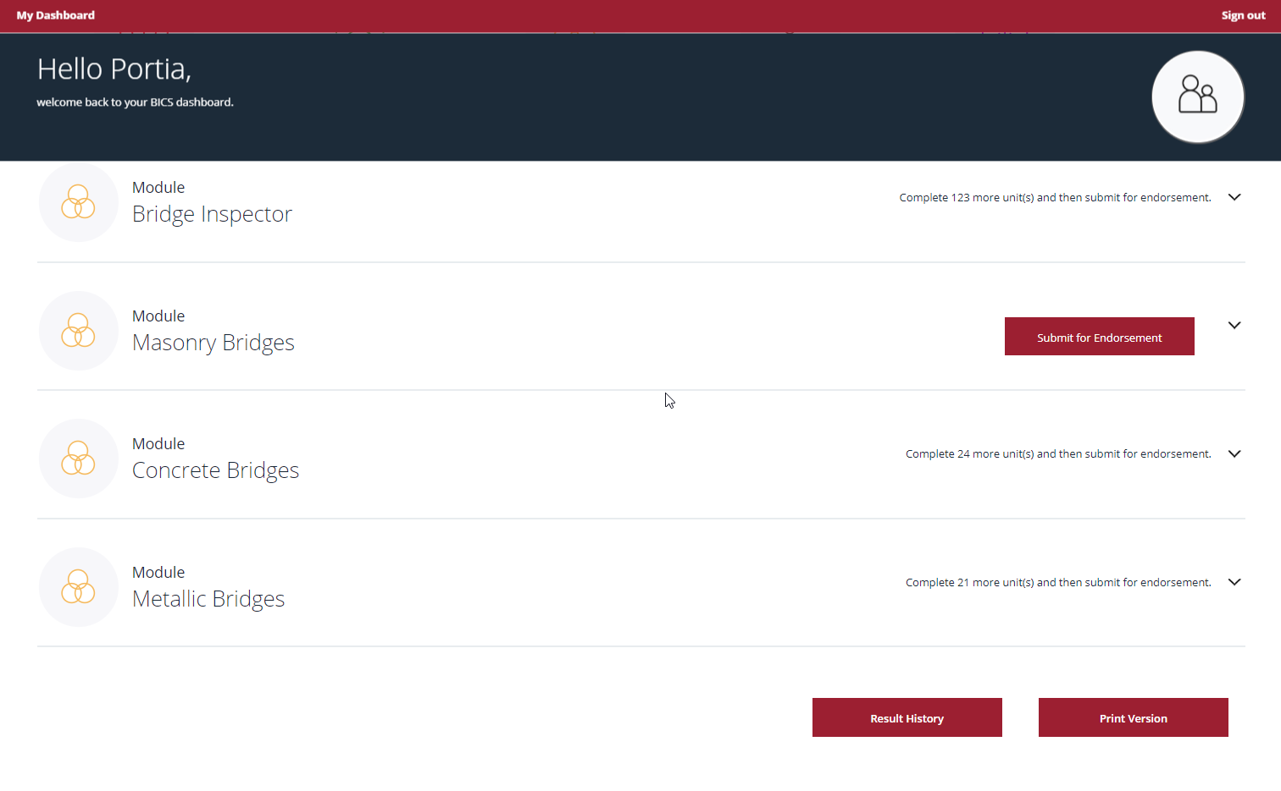

You will see all the modules assigned, expand to see the skills required to complete the module, only once all skills for that module have been actioned will you be able to submit for endorsement.
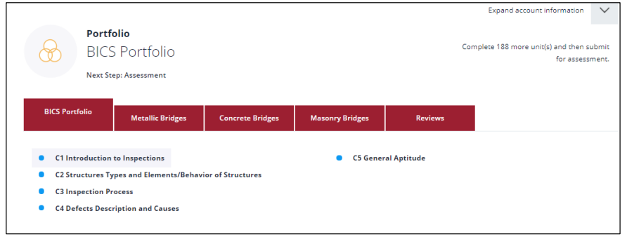
For each module, you will have multiple sections to work through, each containing multiple units.
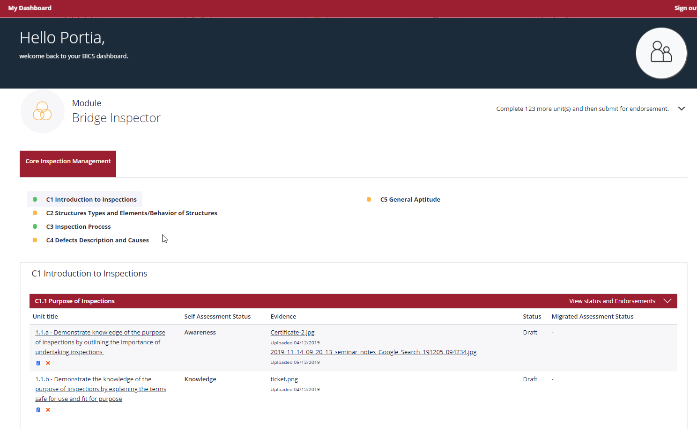
Skills Unit

Module Section

To populate unit detail, click the unit and populate the information and save as draft, you can enter as much or as little and amend multiple times, you can also include multiple files.
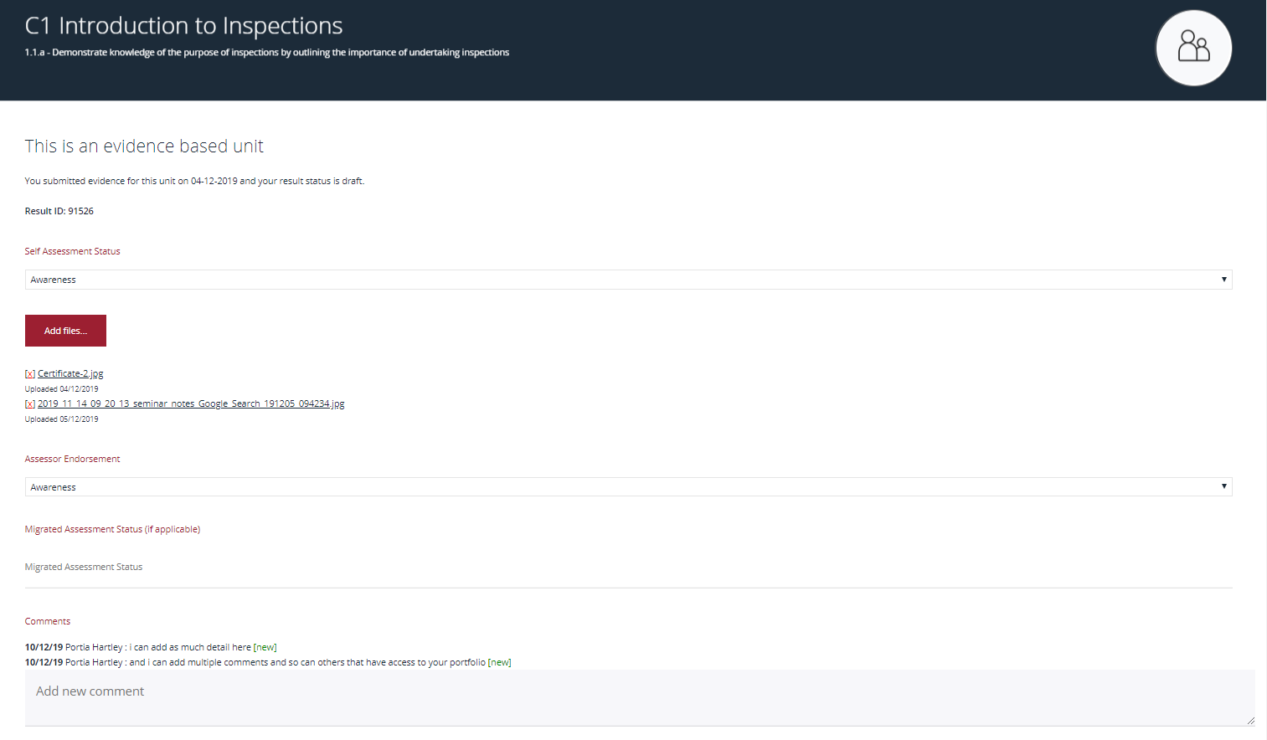
Editing
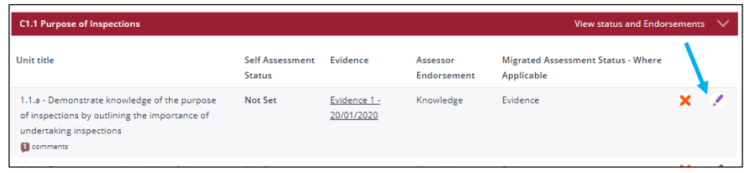
To edit information click on the pen symbol as shown above you will then do through the until details page where you can edit previously populated information.
- Save as a draft if you wish to go back to the unit.
- Save as complete if you have completed the unit.
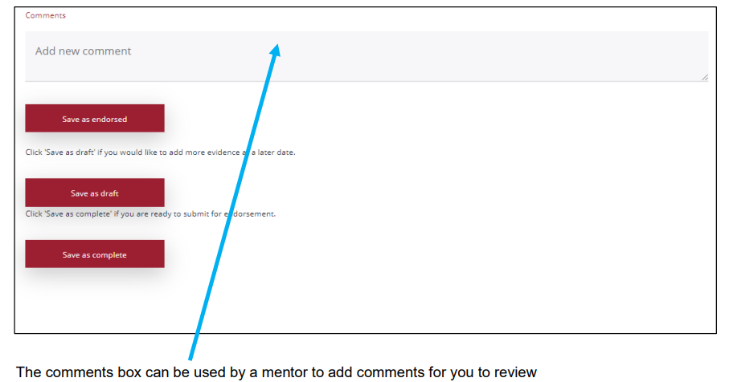
As soon as information has been populated for each unit a submit for assessment button will appear on your portfolio page, click this to alert the Associate Project Manager that your portfolio is complete and it will be assigned to an Assessor.
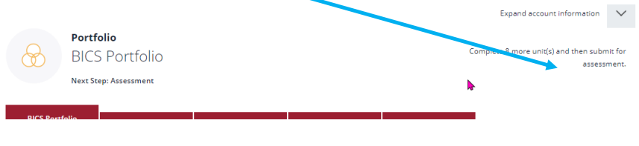
Please note – It is suggested that you annually record your Continuing Professional Development (CPD) here in your e-portfolio, as when you reach the 3rd year anniversary of your BICS Certification (BI/SBI), your records will be re-assessed for evidence of entitlement to certification. (at no extra cost).
Certified BI/ SBI must pay the annual membership renewal fee of £150 (1 April annually) to receive a vaild e-card.

