Bridge Inspector Certification Scheme Candidate Guidance

Contents
1. Purpose 1
2. Scope 2
3. Responsibilities 2
4. Associated Documents 2
5. Process Steps 2
5.1 Candidate Registration 2
5.2 BICS Bursary 4
5.3 BICS Skills + Platform User Guide 4
5.4 Portfolio Completion and Assessment 10
5.5 Professional Interview Assessment 11
5.6 Membership Renewal 13
5.7 Continual Professional Development (CPD) 14
5.7.1 What is CPD? 14
5.7.2 What are the benefits of CPD? 15
5.7.3 Recording CPD 15
5.7.4 Formal 3-year Review 16
5.7.5 Training Record 16
5.7.6 Re-certification Criteria 16
5.7.7 CPD Proposed Activities 17
5.8 Frequently Asked Questions 19

- Purpose
The purpose of this process document is to provide clarity to candidates undertaking the Bridge Inspector Certification Scheme (BICS). This process details the steps from enquiry through to certification.

The management and administration team will provide their services to ensure the success of an international certification scheme for Bridge Inspectors. This scheme is operated on behalf of the UK Bridges Board and the Irish National Roads Authority and is supported by the Bridge Owners Forum, for the benefit of industry. It has the full support of the Department for Transport (DfT).
- Scope
Included within the scope of this work process are BICS candidates, BICS administration team, management team, and Lantra approved assessors.
- Responsibilities
The Associate Project Manager is the document owner, responsible for the content of this work process and is the owner of the Scheme management. Other responsible persons include the Lead Assessor and approved assessors to ensure e-portfolios and professional interviews are managed.
- Associated Documents
- Bridge Inspector Certification Scheme manual.
- Bridge Inspector Certification Scheme Assessor Guidance manual.
- Bridge Inspector Certification Scheme Operating Guidance Manual.
- Bridge Inspector Certification Scheme Report.
- Process Steps
  - Candidate Registration
Bridge Inspector (BI) candidates and Senior Bridge Inspector (SBI) Candidates can register by contacting Lantra at bridges@lantra.co.uk.
The following email will be sent to the candidate upon initial enquiry:
Good Morning (name),

Thank you very much for your enquiry regarding the Bridge Inspector Certification Scheme (BICS).

Please find some information below which I hope you find useful:

- BICS is a certification scheme that validates the candidates experience in the Bridge Inspection sector.

- There are two levels - Bridge Inspector and Senior Bridge Inspector

- Lantra provide an online portfolio system, where candidates upload evidence and narrative to demonstrate how they meet the criteria
- BICS is modular based and consists of a core section plus 3 material units (Metal, Masonry and Concrete)

- Candidates can register on the BICS platform BICS (skills-plus.net) by requesting an invoice direct from Lantra at bridges@lantra.co.uk .

BICS Pricing Structure

The pricing is as follows and are inclusive of VAT and all processing fees. This includes registration, access to the BICS platform*, submission and assessment of portfolio upon completion, a professional interview and an initial 3-year certification fee.
The costs are reflective of the associated assessment fees and therefore it is more cost effective to purchase the entire BICS scheme (Core + 3 modules).

Core + One module | £710 | ü | Cost includes:  - Core+ selected modules*  (*You must select core + one module to become BICS Certified)  - Portfolio assessment costs  - Professional interview cost  (Upon successful pass of e-portfolio)  - Issue of e-card as proof of BICS Certification
Core + Two modules | £740 | ü
Core + Three modules | £770 | ü
Single module | £400 | û | Cost for further modules
Resubmission/Resit | £300 | û | Cost for resubmission of e-portfolio following failure.  Cost for Re-interview following failure
Annual Renewal | £150 | û | Once a Certified Bridge Inspector (BI)/Senior Bridge Inspector (SBI) there is an annual membership fee (renewable on 1 April annually)
*if you do not access your account within the first two years a re-activation fee may be applicable.

  - Bridge Inspector Certification Scheme Bursary
**NEW** BICS BURSARY
The BICS bursary is a grant to support individuals completing the Bridge Inspector Certification Scheme (BICS).
Engineers on an annual income of under £50,000 are eligible to apply for the bursary, which covers £500 towards the cost of BICS accreditation.
The bursary is offered by the Rochester Bridge Trust, to participate in the BICS run by Lantra.
Please find further information here.

You will be required to pay an annual membership fee of £150 and at the 3-year anniversary of certification, the training record including Frequency of Practice and Continuing Professional Development (CPD) for the preceding 3 years will be formally reviewed by LANTRA, with assistance of a BICS registered assessor if appropriate. It is recommended that inspectors seek endorsement from their Inspection Manager or other Senior Manager, to confirm that the submitted evidence is correct and appropriate. An email confirmation from the senior person should be appended to the BICS e-portfolio.
﻿
If you require any further information, please do not hesitate to contact me.

  - BICS Skills + Platform User Guide
A BICS e-Portfolio will be assigned to the candidate by Lantra and made available to them on receipt of payment of candidate registration fee.

The following user guide will assist the BI/SBI to navigate the BICS e-portfolio platform:
Welcome to the BICS Platform.
Lantra have redeveloped the BICS platform to improve performance and support future development.
This guide will give you a few hints and tips for using the BICS platform.
If you need further assistance, please contact the Associate Project Manager at Lantra:
danni.fagan-shaw@lantra.co.uk or email bridges@lantra.co.uk.

Login Page
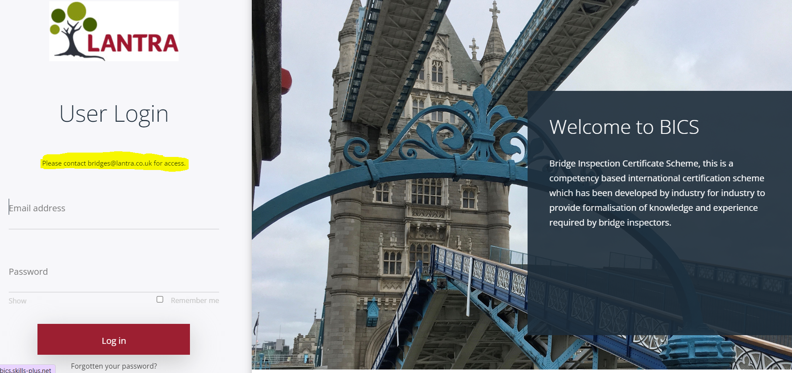
My Profile
This is where your personal profile information is held. You can update your details and add a photo in this section, you also have the option to change your password and username.

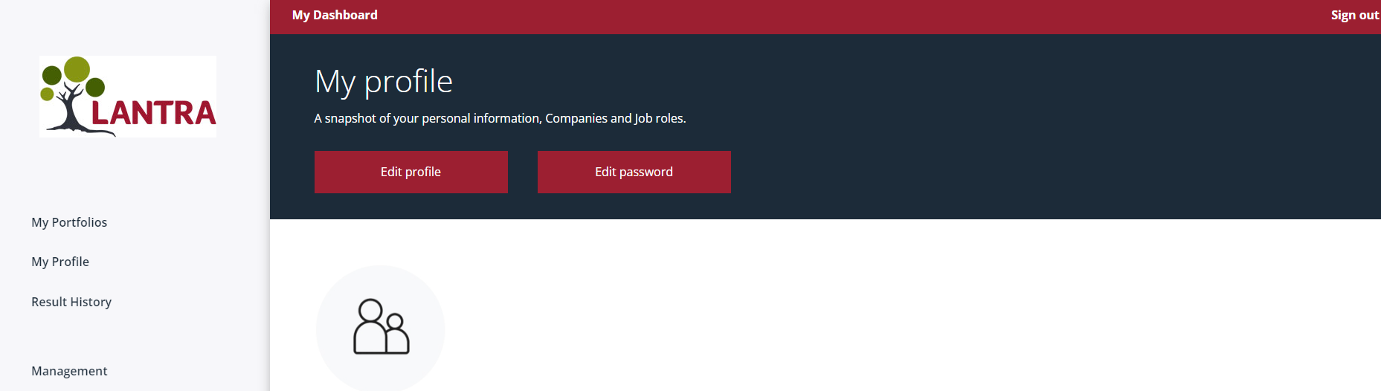
My Dashboard 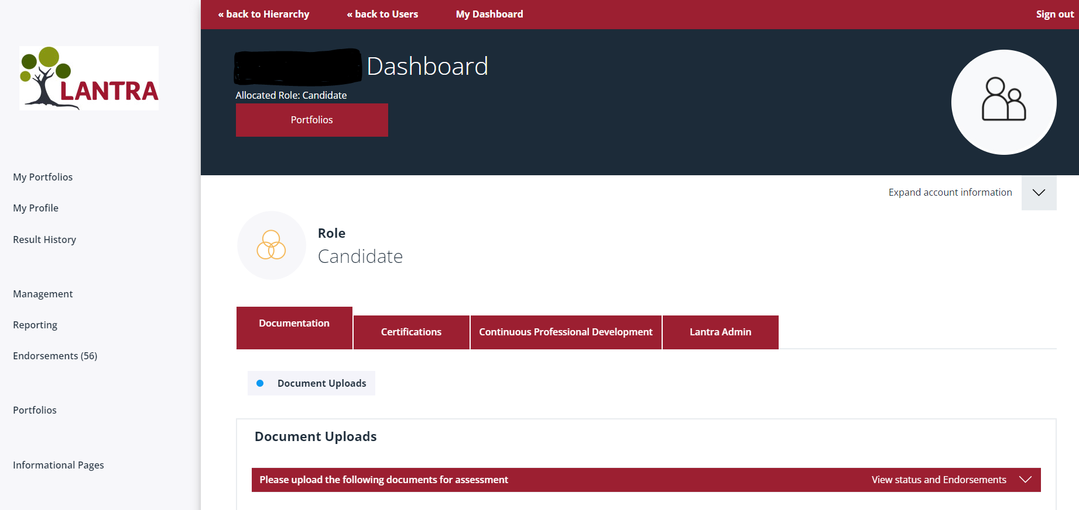
To access your BICS portfolio click on the portfolio button beneath your username as above:
Once in your portfolio you will see the modules you have access to, this will reflect the package that you have purchased.
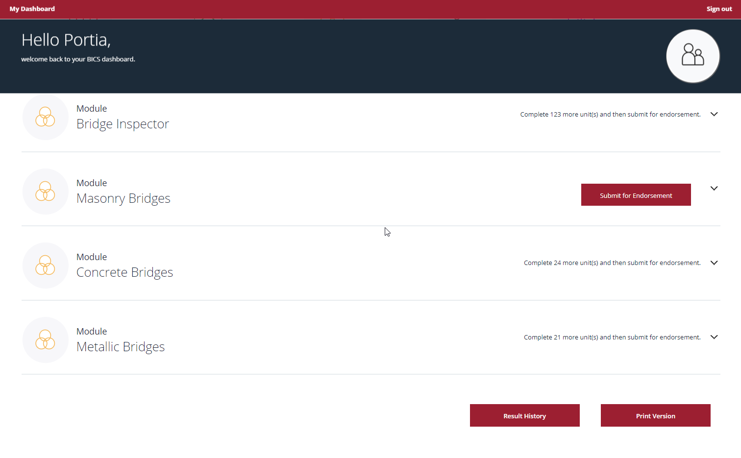

You will see all the modules assigned, expand to see the skills required to complete the module, only once all skills for that module have been actioned will you be able to submit for endorsement.
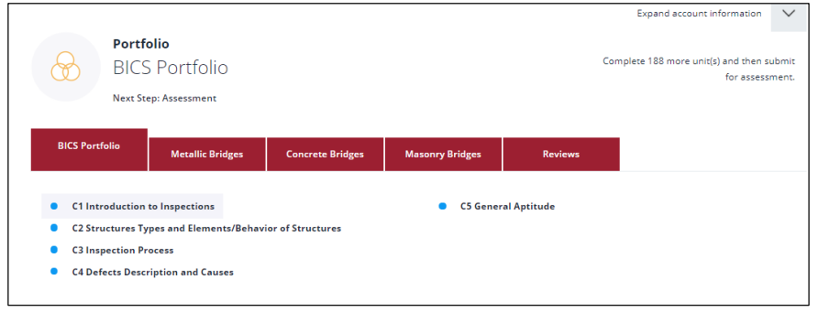
For each module, you will have multiple sections to work through, each containing multiple units.
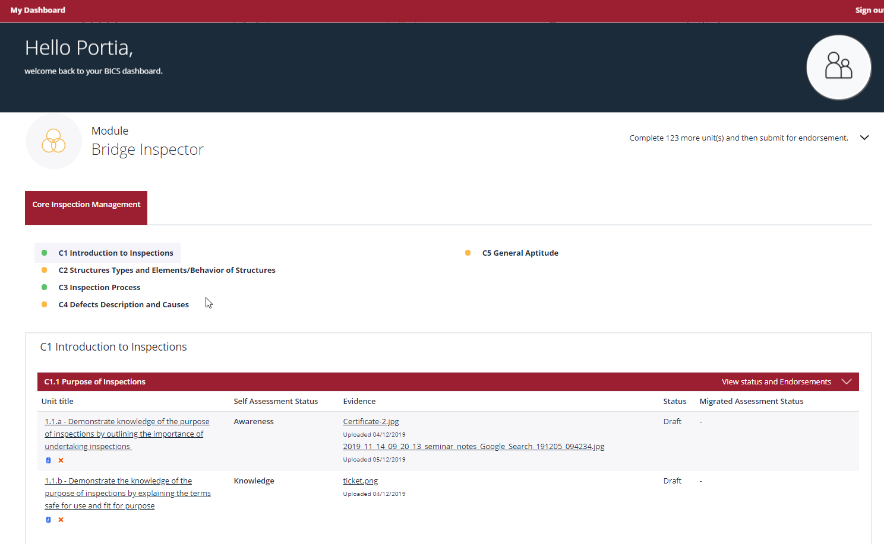
Skills Unit

Module Section

To populate unit detail, click the unit and populate the information and save as draft, you can enter as much or as little and amend multiple times, you can also include multiple files.
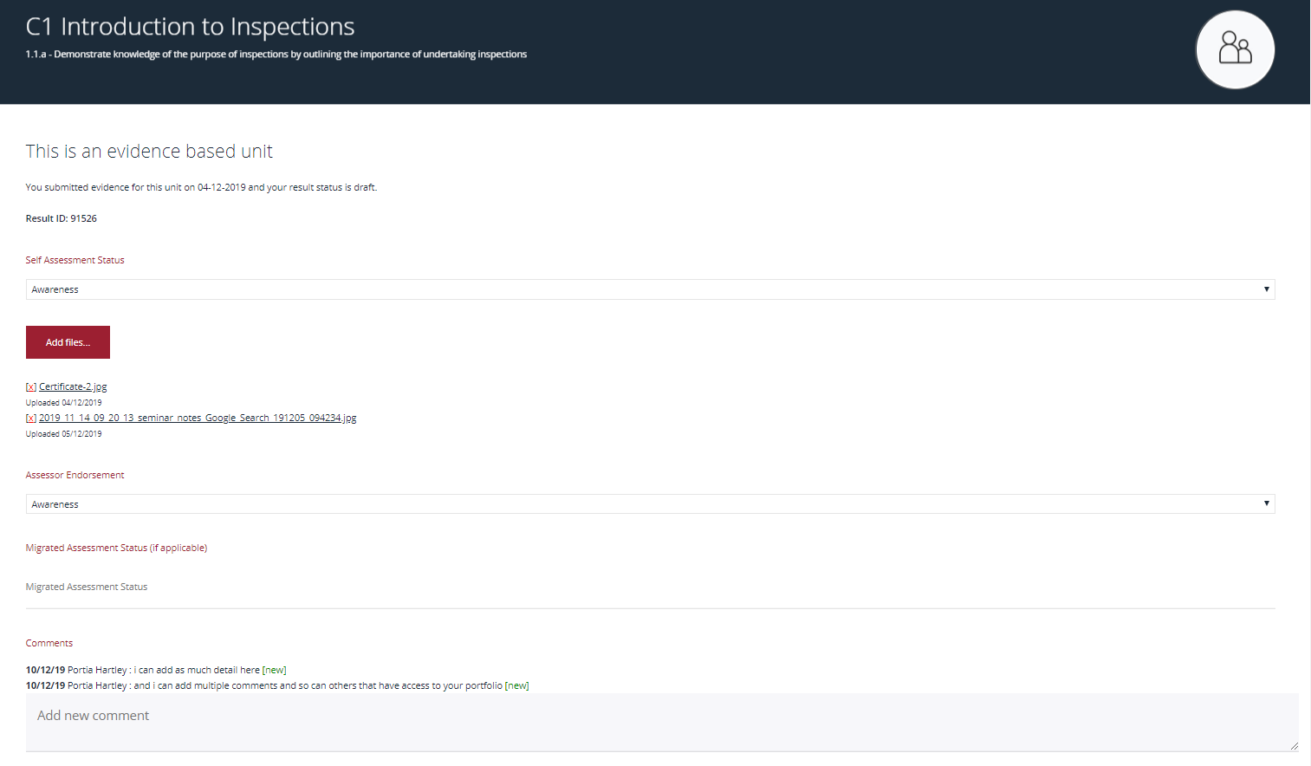
Editing
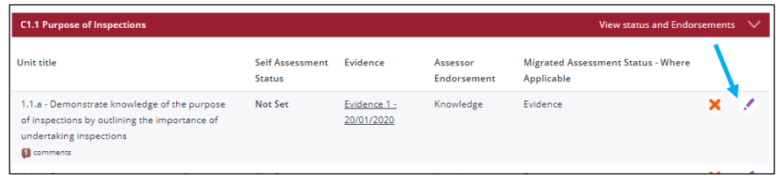
To edit information click on the pen symbol as shown above you will then do through the until details page where you can edit previously populated information.
- Save as a draft if you wish to go back to the unit.
- Save as complete if you have completed the unit.
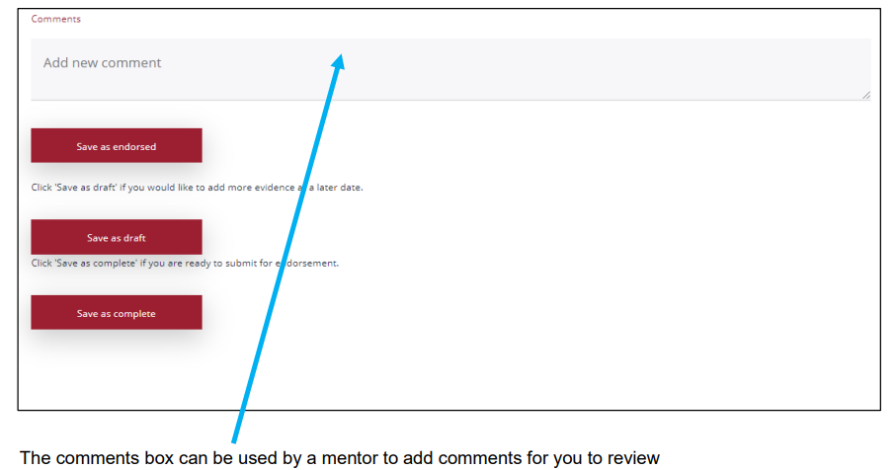
As soon as information has been populated for each unit a submit for assessment button will appear on your portfolio page, click this to alert the Associate Project Manager that your portfolio is complete and it will be assigned to an Assessor.
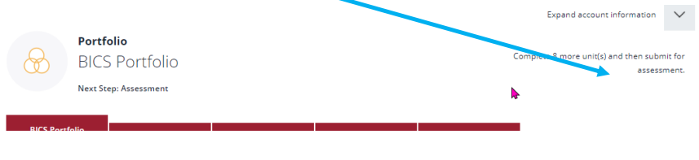
Please note – It is suggested that you annually record your Continuing Professional Development (CPD) here in your e-portfolio, as when you reach the 3rd year anniversary of your BICS Certification (BI/SBI), your records will be re-assessed for evidence of entitlement to certification. (at no extra cost).
Certified BI/ SBI must pay the annual membership renewal fee of £150 (1 April annually) to receive a vaild e-card.
  - Portfolio Completion and Assessment
Candidates record evidence in their e-portfolio to demonstrate that they have the necessary skills to meet each competency at the required level for either Bridge Inspector or Senior Bridge Inspector.
It is essential to record adequate evidence in your e-portfolio to demonstrate that you have the necessary skills to meet each competency. Each unit has a grading level as follows:
- Awareness
- Knowledge
- Experience
- Proficiency

Specific and personalised evidence is important. Guidance is contained within the e-portfolio.

Once a candidate has completed their e-portfolio for all the relevant competencies, the candidate electronically submits this for review via the BICS online e-portfolio. On notification of the submission, Lantra will appoint an Assessor to undertake a review of the e-portfolio units. Lantra must ensure that all units have been completed. Incomplete submissions will be rejected and the candidate will be notified.

It is recommended and encouraged that the candidate appoint themselves a mentor (optional) to support their progress and to review their e-portfolio prior to submission and professional interview.

Once the assessor has completed their e-portfolio review, they will send feedback with recommendations of next steps to Lantra for processing and updating the candidate records.

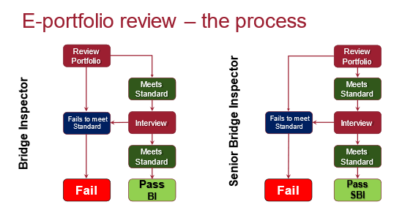

Pass: Lantra provides the result and feedback to the candidate and then liaises with them to schedule a professional interview.
Lantra records a pass or fail and provides feedback to the candidate on behalf of the assessor.

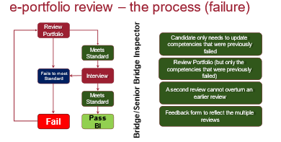
Fail: Lantra advises candidate of failure and details of the assessor report.
Lantra records a pass or fail and provides feedback to the candidate on behalf of the assessor. Lantra resets e-portfolio to enable candidate to improve e-portfolio evidence prior to resubmitting for a 2nd review.

A re-submission of e-portfolio can be rescheduled at an additional cost of £250 + VAT.

Professional Interview Assessment
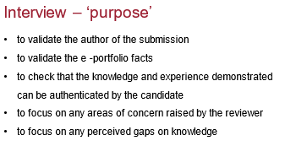
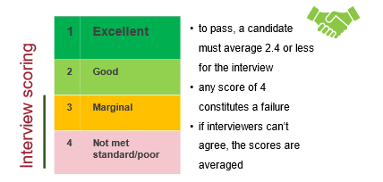
For the professional interview, the following steps are required:
- Lantra will co-ordinate dates with the candidate and 2 x Assessors by sending out a scheduling poll.
- Lantra will schedule the interview into the Candidate and Assessors calendars with MS Teams links
- Interviews will take approximately 1 hour.
- Lantra informs the candidate of the outcome

Pass: Candidate is notified by letter and feedback is given

Lantra issues a BICS skills registration card at the appropriate level, i.e. Bridge Inspector or Senior Bridge Inspector, with the appropriate material types listed on the card. In addition, updates are made to the candidates BICs platform record and moved to ‘achieved’ category.

Fail: Candidate is notified by letter and feedback is given.

A re-sit interview can be rescheduled at an additional cost of £250 + VAT.
If the candidate is unsuccessful in satisfying the requirements of the external Assessors at interview stage, there is the opportunity to appeal or apply to be re-interviewed at a later date. Appeals can be made on an administration basis only and not on technical content.
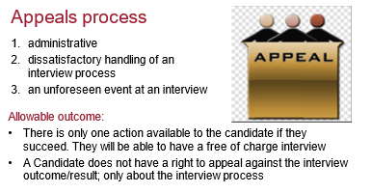

Membership Renewal
Once an Inspector or Senior Inspector are certified, their certification is automatically renewed annually (subject to receipt of the annual subscription). After 3 years there is a formal review and renewal process in place, as detailed below.

Inspectors are advised that recertification is dependent on evidence that they are maintaining inspection activity known as Frequency of Practice. In addition, they will maintain their appropriate training credentials and Continuing Professional Development (CPD). To evidence this, Inspectors and Senior Inspectors should continue to record all Frequency of Practice and CPD on their registered e-portfolio as a training record https://bics.skills-plus.net/. It is recommended that this log of Frequency of Practice and CPD is updated regularly.

Training Record = Frequency of Practice + Continuing Professional Development

The following email will be sent to certified BI/SBI annually:
Dear (insert name here),
Bridge Inspector Certification Scheme
The Bridge Inspection Certification Scheme (BICS) requires you to pay an annual subscription fee and the process is as follows:
- A BICS membership annual fee will be invoiced to you at the end of February annually.
- Payment is expected to reach Lantra by the end of March of that year.
- Your membership will last for one year e.g. from 1st April 2024 – 31st March 2025.
- Every 3rd year you will need to renew your card and record 15 hours evidence of Continual Professional Development (CPD) on the BICS platform.
If you have any further enquiries and can email me at danni.fagan-shaw@lantra or alternatively at bridges@lantra.co.uk.
Yours sincerely,

  - Continual Professional Development (CPD)

5.7.1 What is CPD?
CPD is a term that covers all manner of learning activities that are undertaken to build on and improve skills, knowledge, and behaviours. It enables an Inspector or Senior Inspector to continue in their role and to provide opportunities for further career development.

Within BICS, CPD enables Inspectors of all levels to collect and record practical learning throughout their working lives, shows commitment to the industry and ensures that individuals keep abreast of developments within the industry.

CPD also promotes continued practice within the field of structural inspection to ensure the practical skills required of inspectors are not lost or diminished. This would be particularly important for certified inspectors who take career breaks, enter new roles, or deliver inspection related work as part of a broader engineering role.

5.7.2 What are the benefits of CPD?

Individual Benefits

- It enables development of knowledge and skills, as well as to identify areas for further development.
- It demonstrates a commitment to your profession or work.
- It provides an opportunity to keep abreast of developments within bridge inspection and demonstrates continuing competency and knowledge.

Employer Benefits

- CPD provides reassurance to clients that staff within a company are competent and knowledgeable, committed to their own development and are keeping up with the latest developments within the industry.
- It also provides an employer with evidence of development and assisting with career progression and advancement.

5.7.3 Recording CPD

To gain the maximum benefit from CPD, it is important it is recorded, as this will allow Inspectors to reflect on what has been learnt and how it can be incorporated into work Improvements. CPD should be recorded as part of a training record within the dedicated section on the BICS e-portfolio https://bics.skills-plus.net/ using the template as shown below.

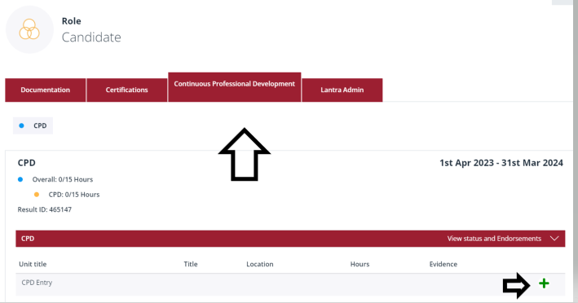

One day of CPD is equivalent to 6 hours of related learning/experience and the Inspector may accrue this in full days or part days as appropriate. With exception classroom training where this extends over at least one full day of 6 hours or greater, is only equivalent to one day of CPD.

The BICS scheme places significant importance on the maintenance of inspection skills. Failure to provide evidence of Frequency of Practice and CPD will result in certification being withdrawn and may affect inspectors work requirements. Reactivation of BICS certification at a later date, will be subject to a further interview and a fee.

5.7.4 Formal 3-year Review

Inspectors and Senior Inspectors should maintain a training record, and evidence of continued active involvement with structure inspections. This should regularly be updated on their BICS e-portfolio https://bics.skills-plus.net/.

At the 3-year anniversary of certification the training record including Frequency of Practice and CPD for the preceding 3 years will be formally reviewed by LANTRA, with the assistance of a BICS registered assessor if appropriate. It is recommended that inspectors seek endorsement from their Inspection Manager or other Senior Manager, to confirm that the submitted evidence is correct and appropriate. An email confirmation from the senior person should be appended to the e-portfolio https://bics.skills-plus.net/.

5.7.5 Training Record

The training record comprising Frequency of Practice and CPD should provide evidence and details of the ongoing skills maintenance undertaken by the Inspector or Senior Inspector. This will generally be a mix of attendance at formal training courses, self-learning and on the job experience.

5.7.6 Re-certification Criteria

- An average minimum of 25 days (150 hours) of Frequency of Practice and 5 days CPD is required per year
- The Frequency of Practice record should consist of evidence of structural inspections undertaken, or planned and overseen, particularly identifying Health and Safety aspects
- CPD evidence should also be provided including relevant training and/or courses attended and appropriate qualifications obtained or renewed

Inspectors applying for renewal of BICS certification with less CPD than recommended will be considered but will be subject to a more detailed review.

It would be expected that Senior Inspectors evidence would show a greater emphasis on inspection of complex or large structures and planning, management and oversight of other inspections and inspection programmes.

Some examples have been provided below of CPD activities, but this list is not exhaustive:

Programming, Planning & Preparing for Inspections (Frequency of Practice)

- Production and review of Risk Assessments and Method Statements (RAMS)
- Programming Inspections
- Procuring specialist equipment and/or contractors (access, welfare, roped access etc.)
- Pre site desk study (review of record drawings, previous inspections etc.)

Undertaking Bridge Inspections (Frequency of Practice)

- Pre site briefings
- General / Principal / Special Inspections
- Inspection write ups – Principal inspection reports, Bridge Condition Indicator forms, recommendations

Activities to improve and expand knowledge (CPD)

- Attend training courses, industry talks, webinars, presentations, discussions
- Independent study
- Shadowing of colleagues
- Obtaining additional relevant qualifications or renewal of training credentials
- Employer reviews undertaken on site or in the office

Given the requirement for specific H&S and Developing Practice related CPD, below are some more specific examples of CPD and again these lists are not exhaustive:

5.7.7 CPD Proposed Activities
H&S
Risk Assessments
Method Statements
Permit to Work preparation and use i.e. Working at Height, Confined Spaces
Task Briefing Sheets
Highways Safety Passport
NEBOSH
PTS
IPAF Certification
PASMA Certification
Confined Spaces Entry/Awareness Training
Specific Site Inductions (Construction and other managed sites)
Toolbox talks
Training delivery i.e., planning safe site visits, working at height, excavations
Suggesting improvements to existing safe systems
Team management – pre-site and during delivery, health screening, etc
COSS/SWL role
IRATA Certification
Commercial Diving Operations Certification
Boat handling i.e., RYA Level 4
“Don’t Walk By” submissions
Company research i.e., sub-contracted access
Traffic Management planning and control
Lessons Learned Control
Incident investigation i.e., bridge strikes, safety incidents
Safety and wellbeing moments
First Aid Training

Developing Practice
Remote inspection techniques
New bridge management systems
Handheld inspection reporting
Developing materials i.e., FRP
New products and markets
New/developing repair techniques
Conferences/exhibitions (related)
  - Frequently Asked Questions

Where can I find the achievement ratings on the e-portfolio?

The achievement ratings are shown within the Bridge Inspector Guidance Manual available on the BICS site.

Do I need to fill out all the self-assessments within the core competencies?

Yes, as the scheme is competency based the requirements for all core modules must be met at either Bridge Inspector or Senior Inspector level, identifiable by selecting the appropriate achievement rating from the drop down box.

What do I need to put in the evidence?

The evidence is a function primarily used to add a brief summary of what skills/experience you have and details of any bridge/structure conferences that you have attended. Supporting evidence can be, but is not limited to; reports, official documentation and additions to your CV.

How do I evidence Awareness and Knowledge achievement ratings?

Questions that require Awareness and Knowledge, do not necessarily require uploaded documentation but documents such as awards/certificates may be added as evidence.

It is important that you summarise within the narrative section the awareness and knowledge you have gained and where from, i.e. conferences/scenarios.

Uploaded documents; what should I add?

It is the responsibility of the candidate to determine the relevance of what is submitted; “official” documentation, reports, assessments and assignments may be used as evidence, thus proving that you have the necessary skills and knowledge to meet the core competencies of the scheme.

Where appropriate the same evidence may be used for multiple units/questions, but the evidence uploaded must clearly identify which units/questions the evidence relates to.

Do I need to complete everything in the e-portfolio before submitting?
Yes, you will need to complete all units and subunits in the portfolio at either Bridge Inspector (BI) or Senior Bridge Inspector (SBI) level – selected at the start of registering as a candidate.

If you leave any of the sub-units within the e-portfolio as “Not Set” your e-portfolio will not be accepted as complete.

Once I’ve submitted my e-portfolio, can I make any amendments?

Once the e-portfolio has been submitted you will not be able to make any further changes. Please double check that you have covered everything you need to before submitting.

Does Lantra or anyone else provide BICS training?

Lantra does not provide any training for the Bridge Inspectors Certification Scheme.

There are a number of universities that offer training courses, which may support knowledge in relation to the requirements of the role of a Bridge Inspector. These courses are not endorsed by Lantra.

Please speak to your employer if you need any training to support your role.

Who can I add as a Mentor and how do I add them?

You can request that a Mentor is added to your BICS e-portfolio. The Mentor will be given limited access rights and will only be able to view your e-portfolio.

Please email bridges@lantra.co.uk with your Mentors details and they will be given access to your e-portfolio.

Who do I contact if I am having problems with my e-portfolio?

If you experience any technical problems with your portfolio, please contract bridges@lantra.co.uk
Where can I get a copy of the Bridge Inspector Manual and other information?

For more information on the scheme and to access useful documents please go to https://www.lantra.co.uk/national-highways-sector-schemes-nhss/bridge-inspectors or contact Danni Fagan-Shaw on 02475 101674 ext. 4105 bridges@lantra.co.uk.

